**This is a tutorial to get started with Deep Cognito.**

1. Open <http://deepcognition.ai/>
2. Login or signup at this site.
3. This would be your homepage, once you are logged into it DeepCognito:

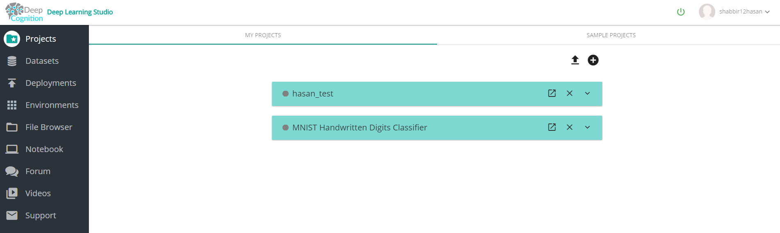

1. Stating the instance, you can use the start symbol to start the instance for your project.



1. You’ll get free 2 hours of compute instance, applicable for new account.

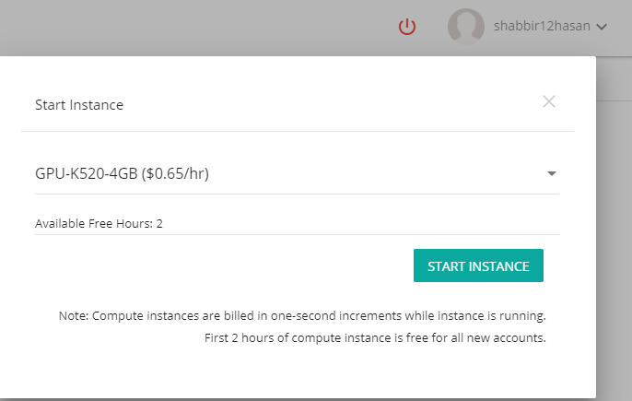

1. Using the +(add) you can create a new project; a new popup will show up. Letting you to choose your project name and description:

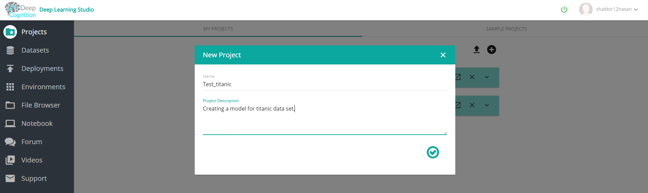

1. After giving project name and description you can move on next. Now you can see your new project added in the top of list. Open that project to select data sets.

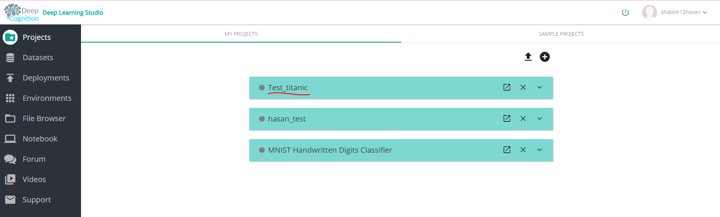

1. Adding titanic data set from provided data sets. Note you can add any data sets on which you want to build a model. Once you load up your data you can select the percentages in which you want to split your training, validation and test data. Also, you can assign value types to your variables.

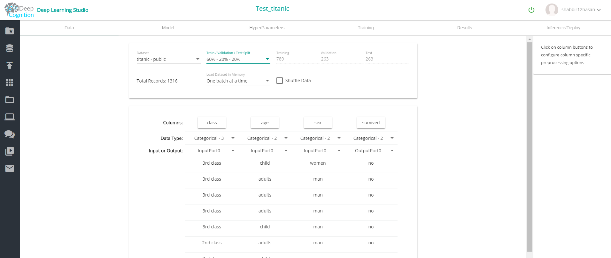

1. Then in the Model tab, selecting magic wand will give you an option to define type of your input data and after that it will create a model for you automatically.

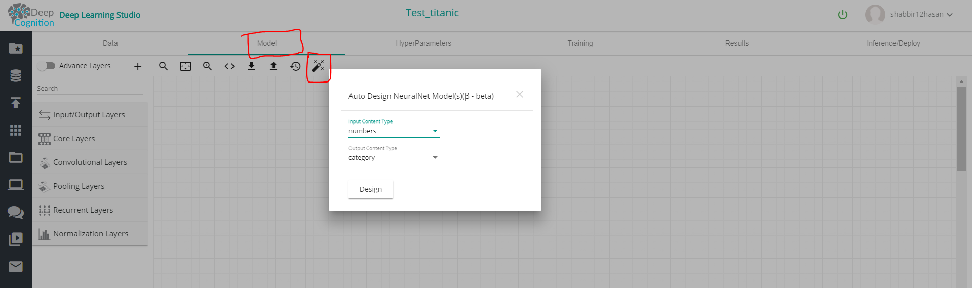

1. After your model is created you can load your model. Further changes could be done on your model.

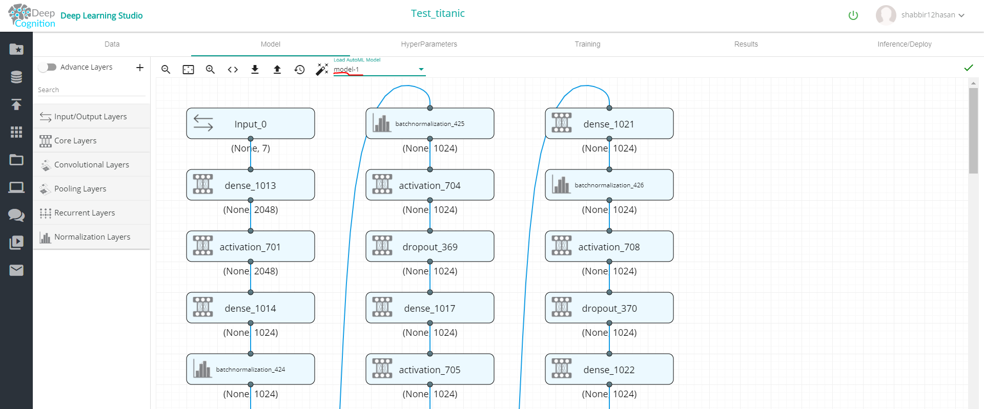

1. In training tab, you can start training your model using test data, you just must click on start training button on the top right. And then model training will start, visuals could be seen in the graphs defining different relationships.

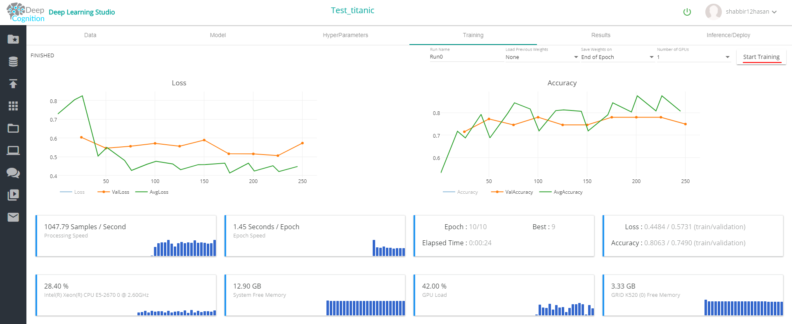

1. Moving to Results tab, you can then load your result from top left panel. It will display detailed graphs for your model.

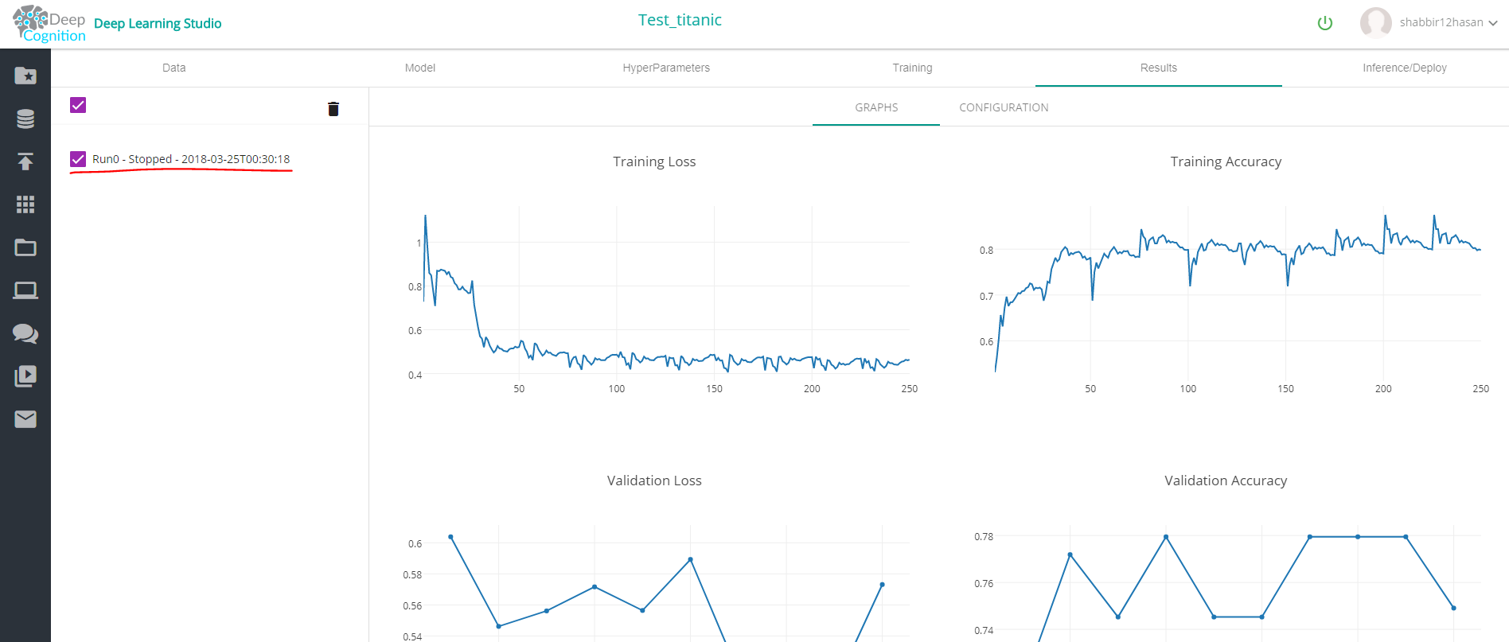

1. In Inference/Deploy tab, you can download your model and can also deploy your model as a web application or API service.

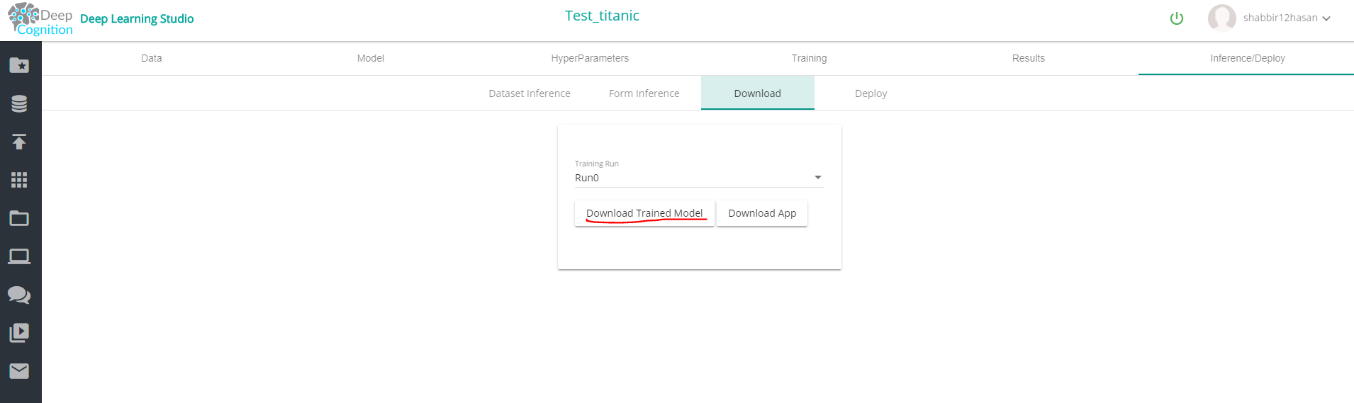

1. Deploying the model:

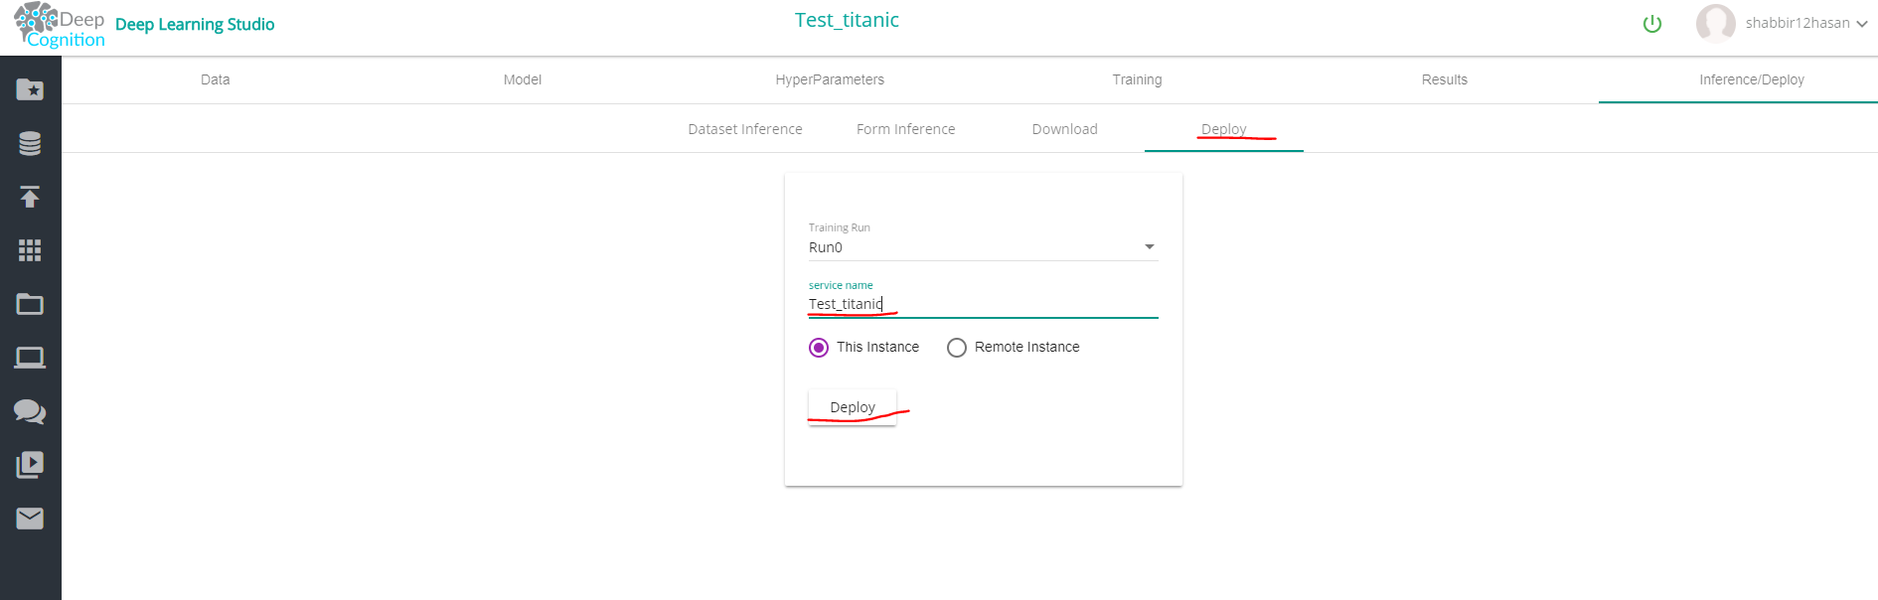

1. Using the model as a web application:

